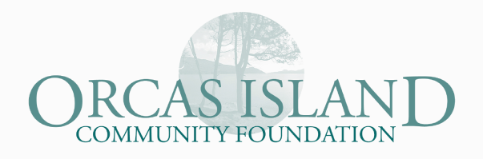
2017 OICF Grant Application Form
2017 Grant Applications must be submitted online no later than
Friday, March 10, 2017

OICF’s mission is to “foster philanthropy to enhance the quality of life on Orcas Island.” OICF’s Annual Grant Program, together with our Holiday Catalog, is one way we try to build community awareness about the good work you do in our community, and raise funds to support your programs. With 111 nonprofits on Orcas, not everyone can be included in every cycle. Our hope is to strengthen as many organizations as possible. Please keep this in mind when submitting your application.

We strongly urge you to discuss your grant proposal ideas with OICF before you submit the final application. Applicants to the 2016 GiveOrcas Holiday Catalog are welcome to apply for the spring cycle, but are strongly encouraged to submit a different program/ask. Contact OICF if you have questions.

Important Updates to the OICF Grant Process
While all grant applications will be considered, OICF will prioritize proposals based the criteria below.
- Does the proposal address a specific need?
- What is the likelihood for success of the proposal?
- Is there duplication of services offered on Orcas for this service/request?
- Does the proposal serve a large number of islanders?
OICF will consider applications to cover a percentage of a nonprofit’s critical or general operating funds. OICF wishes to help nonprofits become as healthy effective and efficient as possible, and be good stewards of community resources. We will likely not consider multiple requests in the same cycle.

All questions have a 1000 character limit (Word.doc will count characters for you). Please stay within this limit and remember that an OICF Grants Committee member will interview you and you’ll be able to elaborate on the details of your request at that time.

In 2016 over $2 million was distributed through OICF—$202,700 in the annual grants process. Consider this application an opportunity to showcase your organization and enhance awareness of the important work you do to make Orcas Island a healthy, vibrant community.

Reporting Guidelines
All reporting requirements are included with the letter of notification; grant reports are due January 16, 2018. Successful proposals of $10,000 or more will be required to meet with a committee member and OICF board or staff member mid-year to discuss the progress and impact of your project.

Questions
Contact Kate Long at OICF: 360-376-6423 or kate@oicf.us.
All Grant applicants complete:

Project/Program Description
Give a brief description of your grant project. Describe the demographics and numbers of people who will be served by this project. Include a timeline.
Max answer length: 1000 characters

Need/Problem Statement
What is the community need/problem your project seeks to address and how did you determine this need or problem exists?
Max answer length: 1000 characters

Project Outcomes
What are expected outcomes (short term and long term) and how will you assess and/or measure these outcomes? I.e. how will you know if your efforts are really solving the problem?
Max answer length: 1000 characters

Cost/Budget
Describe total project costs, and what portion is to be covered by the OICF grant requested. Include non-cash contributions (e.g. volunteer labor, in-kind contributions, etc.). Describe what other funding is being sought or has been received for this project. Is your request for operating expenses? Yes/No
Max answer length: 1000 characters

Project Approval
Has this organization’s governing board approved this project? Check one: Yes/No
Name & email of Board President:

Only grant applicants requesting more than $2,500 complete:

Describe your plans to maintain the project after the funding period. If your request is for operating expenses, how will your operations become sustainable?
Max answer length: 1000 characters

If your grant request is more than $2,500 submit the following materials as attachments:
- Organization’s mission statement
- List of organization’s current board members
- Organization’s annual budget and current financial statement – including balance sheet and profit & loss statement
- If this project is a collaborative effort, the application must include supporting letters from all participating nonprofits and agencies
- If this project is through a Fiscal Agent (i.e. a nonprofit is sponsoring your project) please submit a signed “Fiscal Agent Sponsor Agreement.” (see OICF website).

